Notice
Dear Owners\Occupants:
We will be refurbishing the Dumpster tow carts. The total expected time of this Operation is from:
Monday: June 1
Until
Monday: June 15
Please help us during this time by paying extra attention to your dumping practices.
Remember: Dumpsters are for Kitchen garbage only.
B 1: Only 1 Dumpster.
B2 – B3 –B4: No change, Due to High Demand.
B5-B6-B7: Only 1 Dumpster.
B9 –B10: Only 1 Dumpster.
We highly Recommend the Owners\Occupants to use The pool area dumpster. As it will be regularly monitored and dumped during this time.

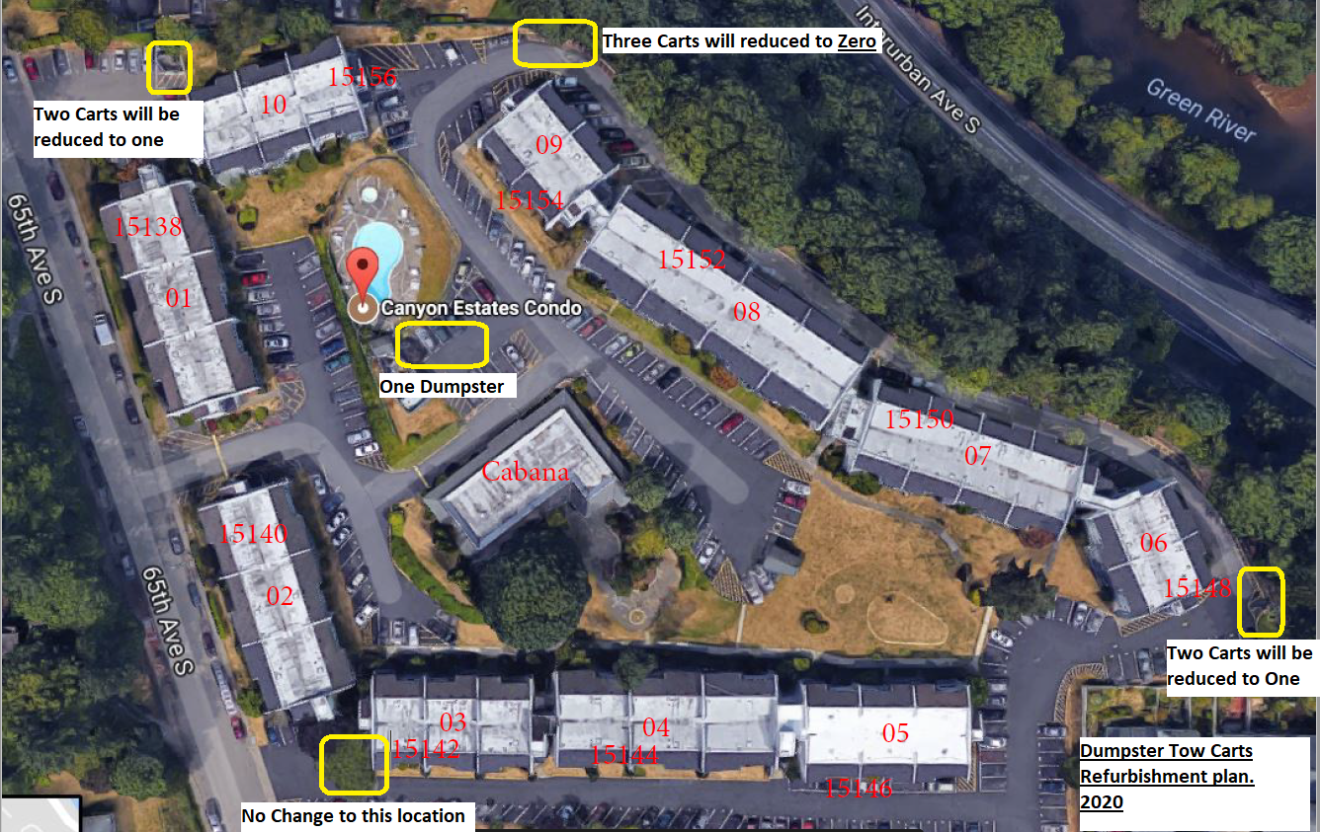

Thank you for your support.
Muhammed Koujan (MK)
Canyon Estates Operations Manager

